Human A/P Bone Notes

The Skeletal System is made up of five parts:

1.

2.

3.

4.

5.

The skeletal system is divided into two sections:

1.

2.

The skeletal system serves five purposes:

1.

2.

3.

4.

5.

There are _________ bones in the human adult. There are about ________ in an infant.

Sesamoid Bones - these bones are embedded in a _____________. They can be found in the:

1. 2. 3.

Their function?

Anatomy of a long bone:

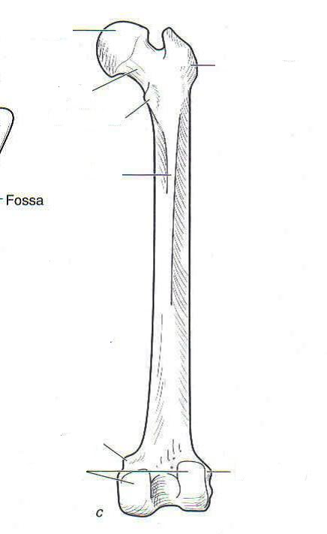

Articular Cartilage -

Meniscus -

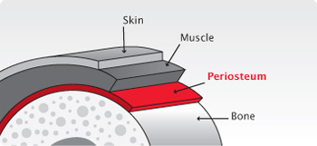

Periostitis (or periostalgia) -
Epiphysial Plates -

A.

B.

Arthritis Types -

A. - cartilage between the bones wears thin and bones rub together.

B. - Autoimmune; the body attacks the cartilage in the joint
causing swelling that can damage joints and organs

C. - the tendon can become inflamed causing discomfort. Treatable.

Break Types -

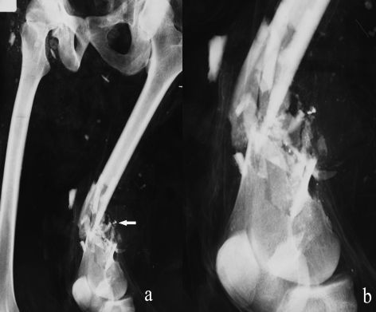
Comminuted -

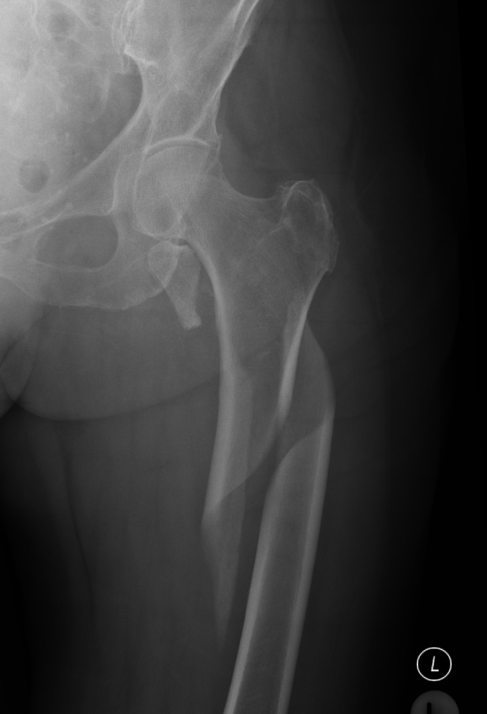 Spiral -

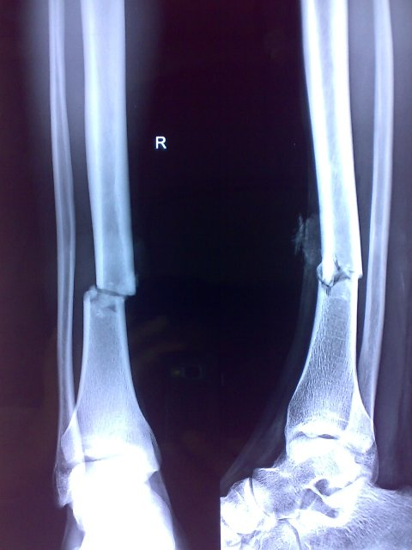 Transverse -

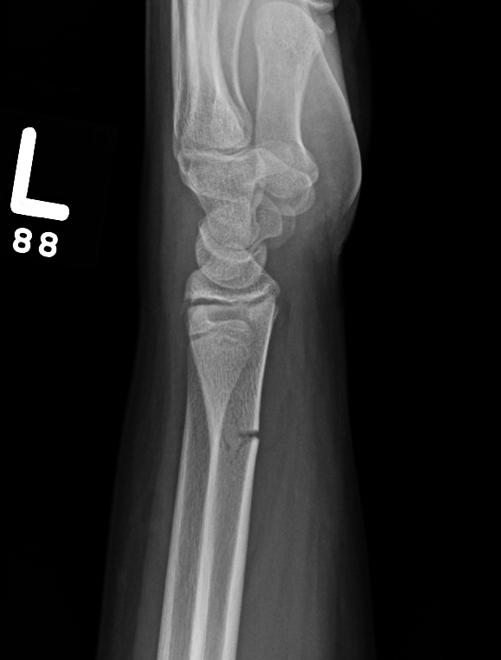 Greenstick -

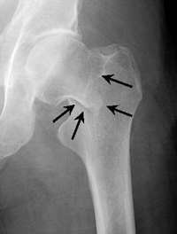 Impact -

