Name____________________

**Cow Femur Dissection**

1. The bone is made of 3 layers:

**Periosteum** - the thin outer skin.

**Callous** **Bone** - the hard white section.

**Marrow** – the softer, red center.

Draw a detailed picture of your bone showing all three layers in the box provided. Label all three parts.

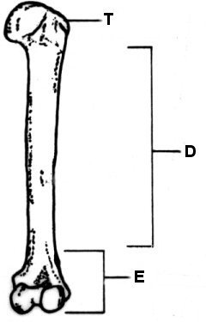

2. Look at the drawing of the femur bone. What section of the femur bone do you think your piece was cut from? Why?

4. Look on the surface of the bone. You may find bits of muscles or tendons. Look at how they attach to the bone and write down as many observations as you can about it. Why are they there?

5. Pull away a part of the periosteum, the skin that covers the bone. Look and see if you can spot small red dots. Red blood cells are produced in the bone marrow. Based on that information, what do you think these red dots are?

6. Based on your observations, do you think the bones in our bodies are alive or dead? Why?

**Chicken Wing Dissection**

**Pre-Lab Questions:**

1. What are some considerations we should take when working with raw meat?
2. What are some considerations we should take when using razor blades?
3. How can you work cooperatively with your group to complete this dissection?
4. Predict the number of muscles and bones that are found in a human arm. Predict how that compares to a chicken.

|  |  |  |  |  |
| --- | --- | --- | --- | --- |
|  | **Predicted Number of Muscles** | **Actual Number of Muscles** | **Predicted Number of Bones** | **Actual Number of Bones** |
| **Human**  **arm** |  |  |  |  |
| **Chicken**  **wing** |  |  |  |  |

1. Biologists often dissect animals in order to understand more about human anatomy and physiology. What does the similarities between humans and other animals suggest about their evolutionary origin?

**Lab Questions:**

1. Make detailed observations of the muscles. What did the muscle tissue look like? What did it feel like? Was it one big muscle, or split into different pieces? How many different muscles can you count in the part of the chicken wing exposed?

1. What are the names of the muscles you can see? Use your resource page showing the muscles in humans to help you.
2. What did the tendons look like? What did the ligaments look like? How could you tell them apart?
3. Look at the attachment points for the tendons of the bicep. Use the simple diagram to draw in the bicep. Label the origin (immovable) and insertion point (movable) for the bicep. When the bicep contracts, which way will the bone move? Indicate this on the diagram.

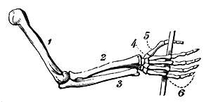

1. Ulna
2. Radius
3. Humerous
4. By pulling on the bicep muscle you are simulating a muscle contraction. Describe how the shape of a muscle changes when it contracts and when it is relaxed.
5. Muscles are always found in pairs, one on each side of the bone. Imagine the tricep was cut. How would that change the ability to move the wing? Use your observations from looking at the triceps and biceps to explain what would happen. Why is it important to have both pairs of muscles working?
6. Make a detailed observational drawing of the chicken wing in the space below. Include labels showing skin, fat, tendons, ligaments, cartilage, names of bones and names of muscles.
7. What did the cartilage look and feel like? How does cartilage help the joints to move smoothly?
8. ~~Compare the inside of the chicken wing bone to the inside of a cow femur. How do they look similar? How do they look different? What is the material on the inside of the bone called and what is its function?~~

**Post-Lab Questions:**

1. One of the key principles of physiology is that “form follows function”. Describe one example of how the shape or structure of a part allowed it to do its job properly.
2. Organ systems depend upon one another in order for the organism to function. Describe how the muscular system and skeletal system are highly integrated.

**Chicken Dissection Observational Drawing Rubric**

**Name________________________**

|  |  |  |  |  |
| --- | --- | --- | --- | --- |
| Learning Target | Attributes | **JB**  ***(0 pts)*** | **Ap**  ***(1 pt)*** | **M**  ***(2 pts)*** |
| **LT #1** I can make careful and accurate scientific observations and drawings and make reasonable inferences supported by evidence. | Size Drawing fills the entire space. |  |  |  |
| **Details**  Good use of details, includes patterns or shading, and small structures. |  |  |  |
| Accuracy Correctly identifies each of the major muscles and bones in the wing. |  |  |  |
| **Titles**  Includes labels showing various structures. |  |  |  |
| **Craftsmanship**  Shows best effort. |  |  |  |
| **OVERALL:** | | | | **/10 pts.** |

**Comments:**

**Chicken Wing Dissection**

# Instructions

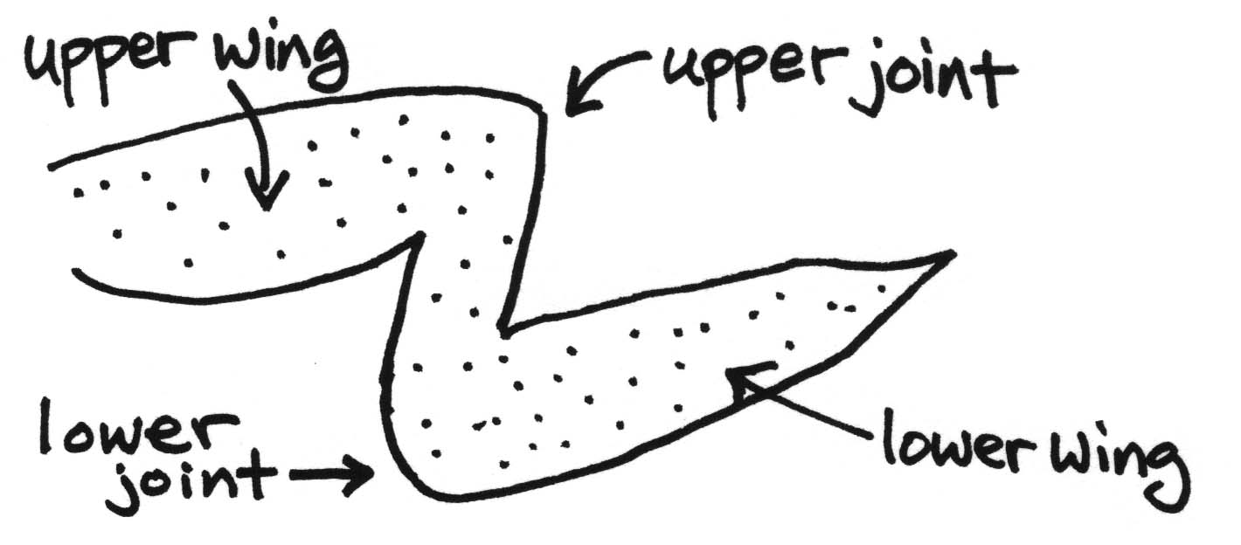

**Follow These Directions Carefully, Do Not Skip Steps!**

**FIRST DISSECTOR:____________________**

1. Use your fingers to peel the skin away from the muscle near the upper wing.
2. Now, using the tweezers and razor, carefully remove all of the skin except the skin on the wing tip. *Be careful not to cut the tendons or ligament.*
3. Carefully examine the muscles and make observations in the space provided. **(Write response to Lab Question #1 and 2)**
4. *Gently* try to pull a muscle from the bone. Does it come off? Try to find out why. **(Write response to Lab Question #3 and 4)**

**STOP AND SWITCH ROLES. NEW DISSECTOR:____________________**

1. Find the biceps and use your fingers to gently pull the bicep. Look at how the wing moves. Now, find the triceps and use your fingers to gently pull on the triceps. Take turns pulling back and forth on the bicep and tricep muscles and observe the movement that happens when a specific muscle is pulled. **(Write response to Lab Question #5 and 6)**

**STOP AND ALL GROUP MEMBERS MAKE AN OBSERVRATION DRAWING.**

1. Make an observational drawing of your chicken wing in the space provided. Check rubric to be sure it is complete. **(Write response to Lab Question #7)**

**SWITCH ROLES. NEW DISSECTOR:____________________**

1. Remove the tricep by cutting the tendons connecting it to the bones. Pull on the bicep and see how removing the tricep affects your ability to move the wing.
2. Locate the joint between the upper and lower wing. Observe the cartilage that covers the ends of each bone at the joint. **(Write response to Lab Question #8)**

**SWITCH ROLES. NEW DISSECTOR:____________________**

1. Break one of the two lower wing bones. Examine the broken bone and observe the inside of the bone. **(Write response to Lab Question #9)**
2. When everyone is done observing, follow instructions on how to safely dispose of razor blades and dissection materials.

